Sending same email to lots of people using mailchimp email template

Send mail for company promotions and marketing using mailchimp

<https://mailchimp.com/pricing/>

Check contacts and audience

audience is kind of group

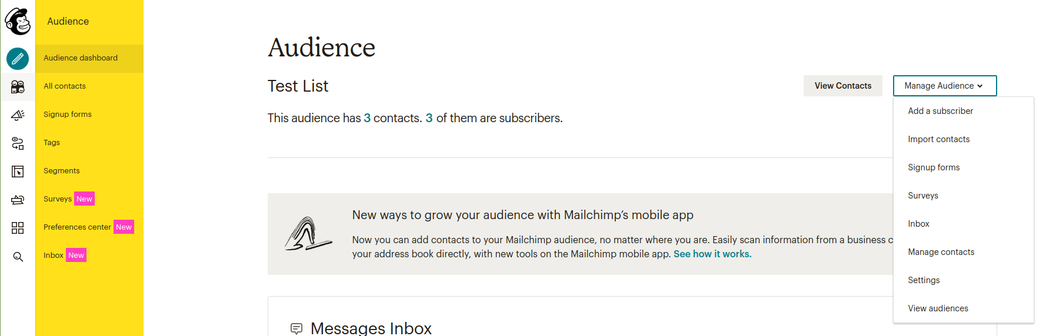

[Import contract](https://mailchimp.com/help/import-contacts-mailchimp/) contract should be csv format

create few tags related to your business

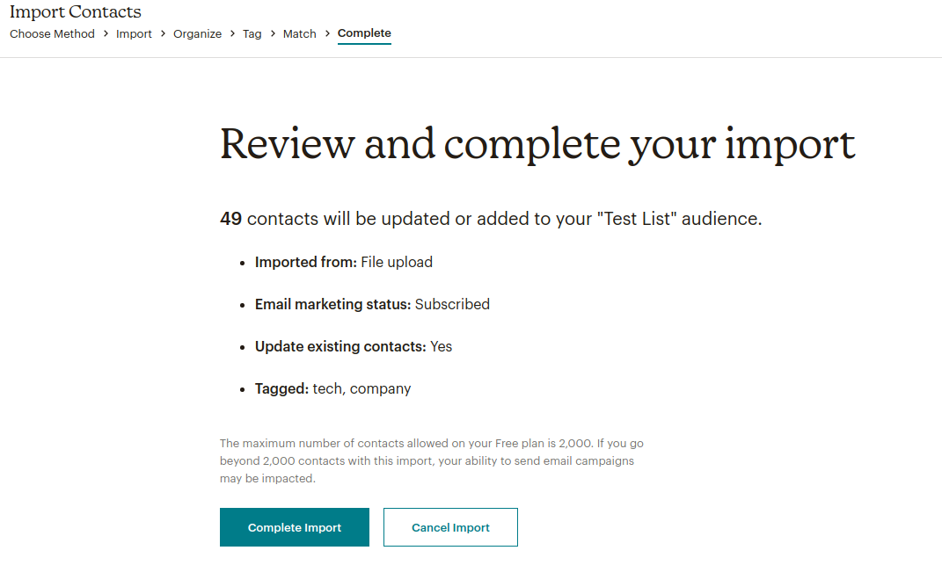If everything is right start campaign

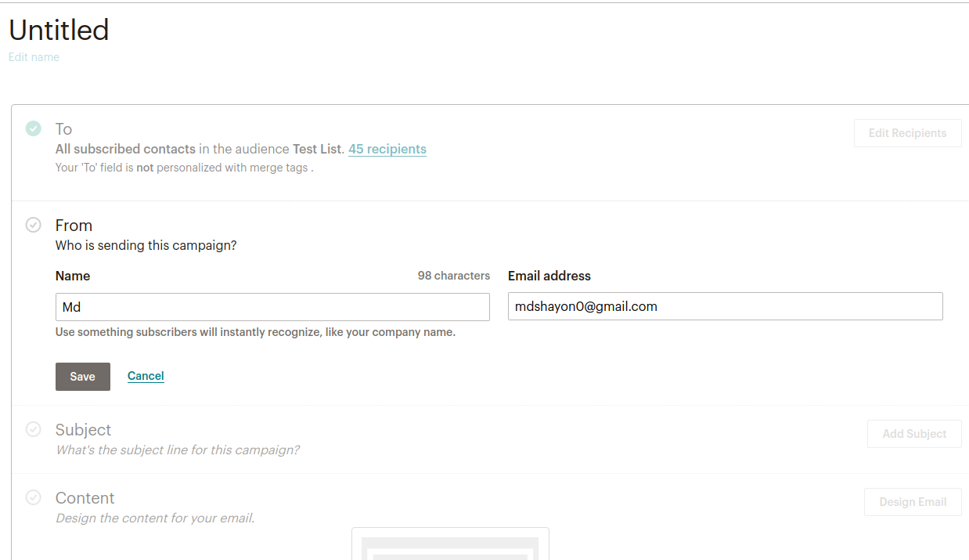

Set name for sender and email from where email is sending

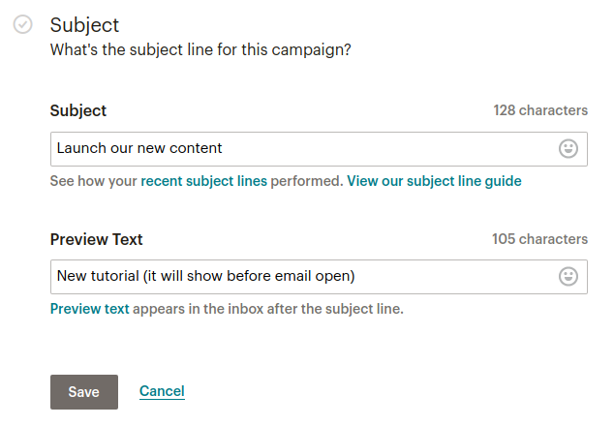

Write subject of the email

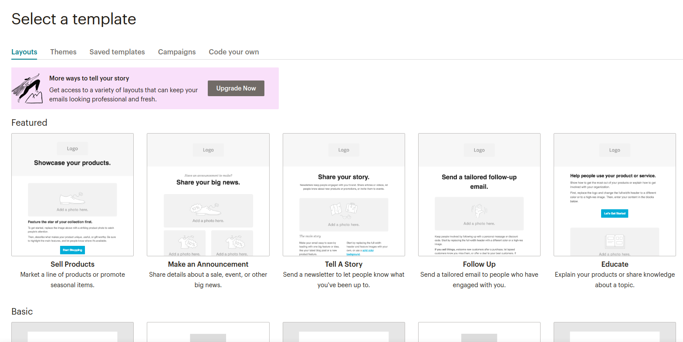Change design

Select any of the template and customize it

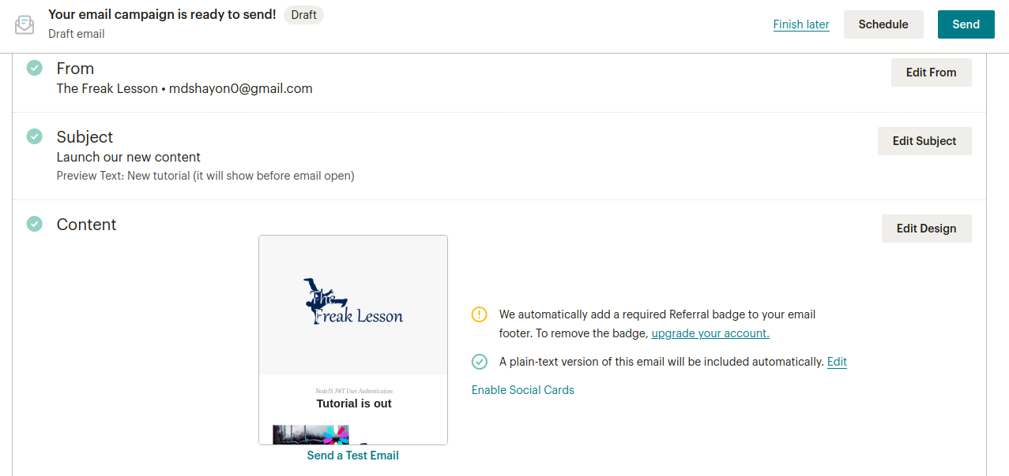If everything is done send the mail or schedule to send letter